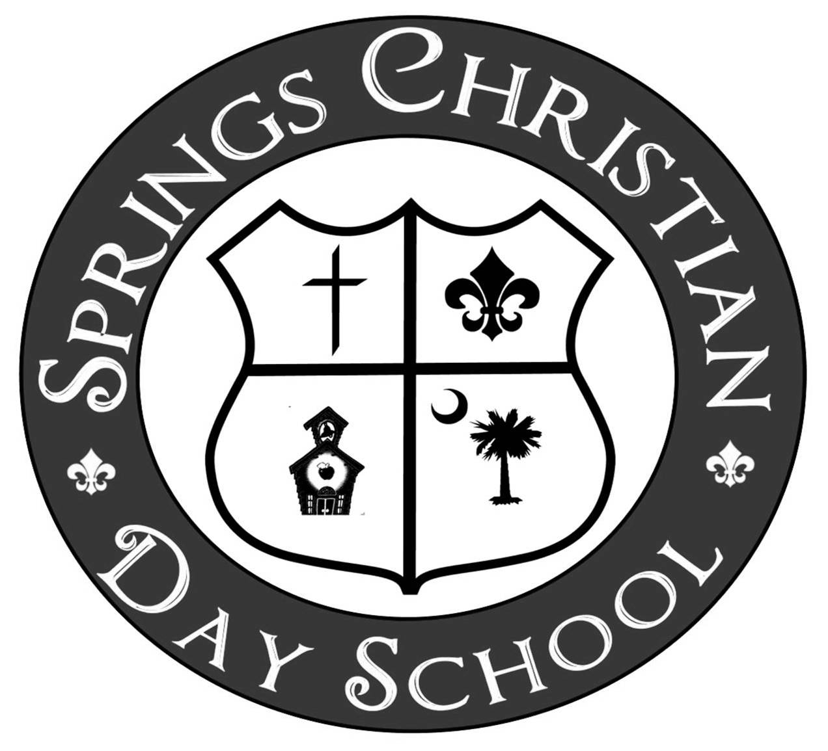

GENERAL APPLICATION AND ENROLLMENT GUIDELINES
2024-2025 School Year

- All applications must be completed in full, signed by parent/legal guardian, and must be accompanied by the full registration fee (Check, Cash or Money Order). Incomplete applications or applications returned without the registration fee will not be processed. Accordingly, we will not accept the registration fee without a completed application.

- Your account MUST be current, including February tuition paid in full, before we accept any new applications.

- The FALL registration fee MUST be paid separately by cash, check or money order from any other fees.

- A current South Carolina Certificate of Immunization is required for all new students. It must be received in the SCDS office by August 1, 2024. Returning students will be notified if an updated immunization is needed.

- Students enrolling in the 3K, 4K and 5K classes must be FULLY toilet trained and able to use the restroom unassisted.
- Children must enroll in a class equal to the age he or she will be on or before September 1. For example, a student seeking enrollment to the 3-year-old preschool program must have had his 3rd birthday on or before September 1. SCDS does not allow students to skip grade/age levels. The assignment of students to classes of teachers is the sole responsibility of the administration of SCDS. Children may not transfer from one class to another class because of preference for a particular teacher or classmate.
- All applications will be dated as they are received in the SCDS office. Space is limited and applications are processed on a first come, first-serve basis. The application and the registration fee must be submitted at the same time.
- Current students, siblings of current students, and children of members of Boiling Springs First Baptist Church and First Baptist North Spartanburg are entitled to participate in early registration.
- Non-Discrimination Policy: Springs Christian Day School is operated as an educational institution for the benefit of the families in our community. Students are admitted without regard to race, color, or national or ethnic origins.
- Special considerations will be given to students of staff and faculty of Springs Christian Day School and BSFBC.
- Students must show a behavioral history that matches the behavioral expectations of Springs Christian Day School. SCDS does not accept students who have been repeatedly suspended or expelled from previous schools.
- Due to staffing and resource constraints, SCDS is unable to provide services for students with emotional, behavioral, or academic problems or students who have been diagnosed with special education needs.
- New families may schedule a meeting with the director.
- If you have any questions regarding these guidelines or your child’s status, please do not hesitate to call the school office at (864) 578-2148.

